**Building in International Waters**

*Forum:* SECURITY COUNCIL

*Date of inception:* 01/07/2024

*Submitter:* THE DEPARTMENT OF PROTOCOLS

*Co-submitters:* THE SECRETARIAT

THE SECURITY COUNCIL,

1. *Observing* the principle of freedom of the high seas within international maritime law,
2. *Recognising* the ability of a state to use “global commons” oceans for various activities,
3. *Concerned* by the implications of this freedom for certain states, with particular emphasis on freedom to build and extract natural resources,

1. Having consideredoceans as crucial for activities such as shipping, fishing, energy production, and tourism. Encourages all efforts to strengthen global governance for oceans by achieving its laws by UNCLOS (United Nations Convention on the Law of the Sea).
2. Any artificial land mass created is classed as the property of the country that created it.
   1. Countries have the freedom to build artificial landmasses in international waters.

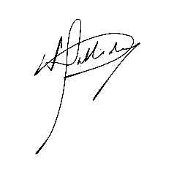**Signatories**

______________________________

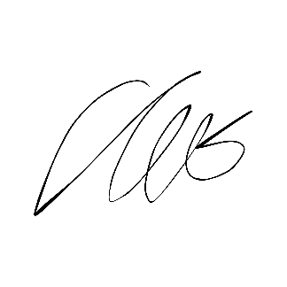Izzy Halliday, on behalf of the Department of Protocols  
Deputy Head of Protocols

______________________________

Imri Tal, on behalf of the Secretariat  
Secretary-General